**Supplementary Information**

**Chromosome-scale assembly of the *Dendrobium chrysotoxum* genome enhances the understanding of orchid evolution**

Yongxia Zhang1, Guo-Qiang Zhang2,3, Diyang Zhang4, Xue-Die Liu4,5, Xin-Yu Xu4, Wei-Hong Sun4,5, Xia Yu4, Xiaoen Zhu1, Zhi-Wen Wang9, Xiang Zhao9, Wen-Ying Zhong9, Hongfeng Chen6, Wei-Lun Yin4,8, Tengbo Huang1*, Shan-Ce Niu7*, Zhong-Jian Liu4*

**Running title:** *Dendrobium chrysotoxum* genome

Content

Supplementary Figures 4

Supplementary Figure 1. Genome size and heterozygosity estimation using 17 *K*-*mer* distribution. 4

Supplementary Figure 2. Gene structure prediction statistical results. *D. chrysotoxum* compared with the genetic elements of related species. Window refers to the length represented by each point on the horizonal coordinate. 5

Supplementary Figure 3. Sequence divergence rate of four different TEs using RepeatMasker annotation. 6

Supplementary Figure 4. Sequence divergence rate of four different TEs using *de novo* annotation. 7

Supplementary Figure 5. Classification and distribution of homologous gene families among species. 8

Supplementary Figure 6. Phylogenetic tree constructed based on the filtered single-copy gene family; each branch length represents the neutral evolution rate. 9

Supplementary Figure 7. Phylogenetic analysis of SWEET genes from *A. thaliana*, *D. chrysotoxum*, *P. equestris*, *A. shenzhenica,* and *D. catenatum*. 10

Supplementary Figure 8. Collinear map of *D. chrysotoxum* (GuChui) and *D. catenatum* (DCAT). 11

Supplementary Figure 9. Syntenic depths map of *D. chrysotoxum* (GuChui) and *D. catenatum* (DCAT). 12

Supplementary Figure 10. Collinear diagram of *D. chrysotoxum* (GuChui) and *P. aphrodite* (PAPH)*.* 13

Supplementary Figure 11. Collinear depth distribution map of *D. chrysotoxum* (GuChui) and *P. aphrodite* (PAPH)*.* 14

Supplementary Figure 12. *Ks* distribution identified by different methods.. 15

Supplementary Figure 13. Phylogenetic analysis of MADS-box genes from *D. chrysotoxum*, *Arabidopsis thaliana* and *Oryza sativa*. Maker, *D. chrysotoxum*. 16

Supplementary Figure 14. Phylogeny tree of AAO from *Dendrobium chrysotoxum, Dendrobium catenatum, Apostasia shenzhenica, Phalaenopsis equestris,* and *Arabidopsis thaliana* constructed by the PhyML with the Jones–Taylor–Thornton (JTT) matrix-based model. 17

Supplementary Figure 15. Analysis of *D. chrysotoxum* Hsp90 genes. 18

Supplementary Tables 19

Supplementary Table 1. Summary of DNA sequencing data. 19

Supplementary Table 2. Summary of Pacbio assembly results of *D. chrysotoxum*. 20

Supplementary Table 3. BUSCO assessment of the *D. chrysotoxum* and *P. aphrodite* genomes’ assembly. 21

Supplementary Table 4. Chromosome length by Hi-C assembly. 22

Supplementary Table 5. Summary of HiC-assembly results. 23

Supplementary Table 6. Summary of orthologous gene families in 17 sequenced plant species. 24

Supplementary Table 7. BUSCO assessment of the *D. chrysotoxum* and *P. aphrodite* genomes’ annotation. 25

Supplementary Table 8. Prediction of gene structures in *D. chrysotoxum*. 26

Supplementary Table 9. Statistics of non-coding RNA in the *D. chrysotoxum* genome. 27

Supplementary Table 10. Statistical results of repeat sequences. 28

Supplementary Table 11. Statistics of repeat sequences in *D. chrysotoxum*. 29

Supplementary Table 12. Statistical results of functional annotation. 30

Supplementary Table 13. Gene Ontology (GO) enrichment results of significantly expanded gene families in *D. chrysotoxum* (see separate files). 31

Supplementary Table 14. Statistical results of whole gene collinearity analysis. 32

Supplementary Table 15. List of MADS-box genes identified in *D. chrysotoxum*. 33

Supplementary Table 16. The expression of genes in carotenoid biosynthesis pathway and regulatory mechanisms. 35

Supplementary Table 17. The expression of gene in abscisic acid biosynthesis pathway. 36

Supplementary Table 18. The expression of genes in Ethylene biosynthesis pathway and regulatory mechanisms. 37

# Supplementary Figures

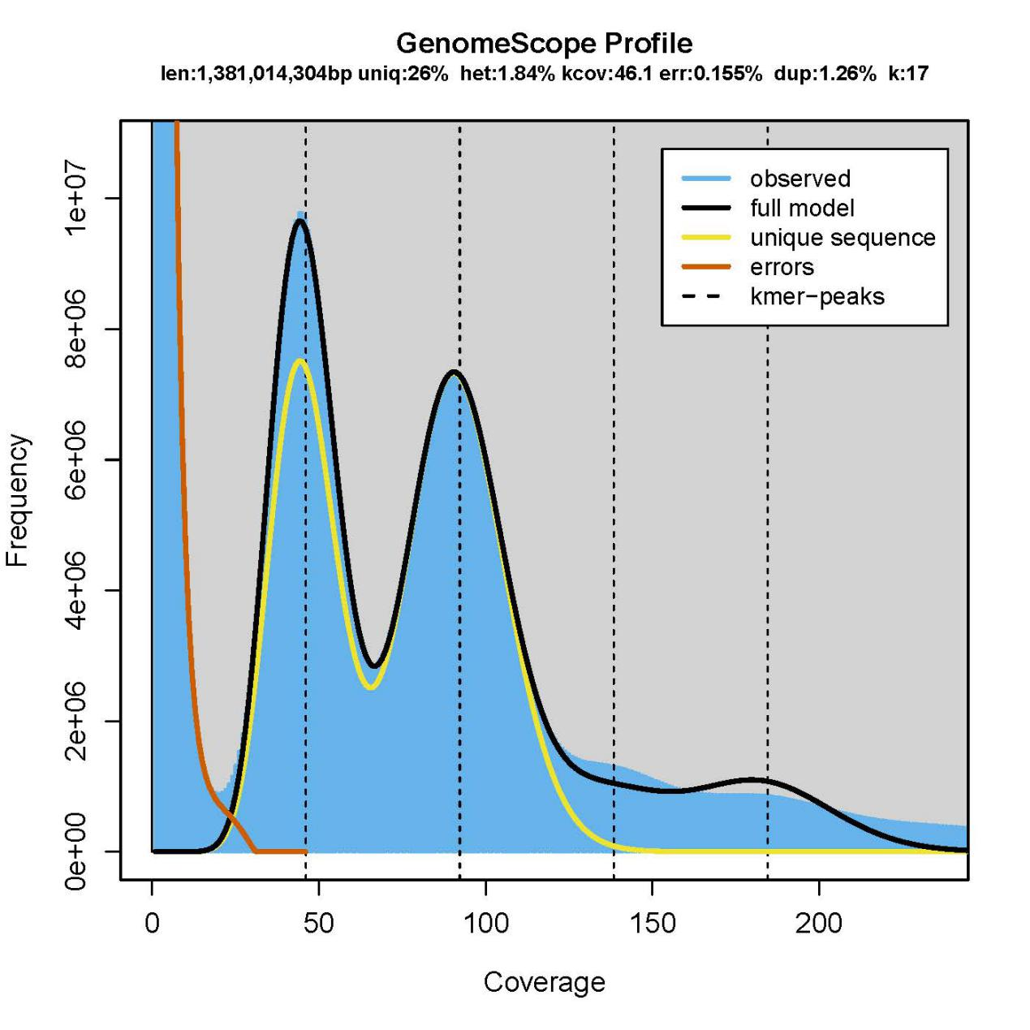

## Supplementary Figure 1. Genome size and heterozygosity estimation using 17 *K*-*mer* distribution.



## Supplementary Figure 2. Gene structure prediction statistical results. *D. chrysotoxum* compared with the genetic elements of related species. Window refers to the length represented by each point on the horizonal coordinate.



## Supplementary Figure 3. Sequence divergence rate of four different TEs using RepeatMasker annotation.



## Supplementary Figure 4. Sequence divergence rate of four different TEs using *de novo* annotation.

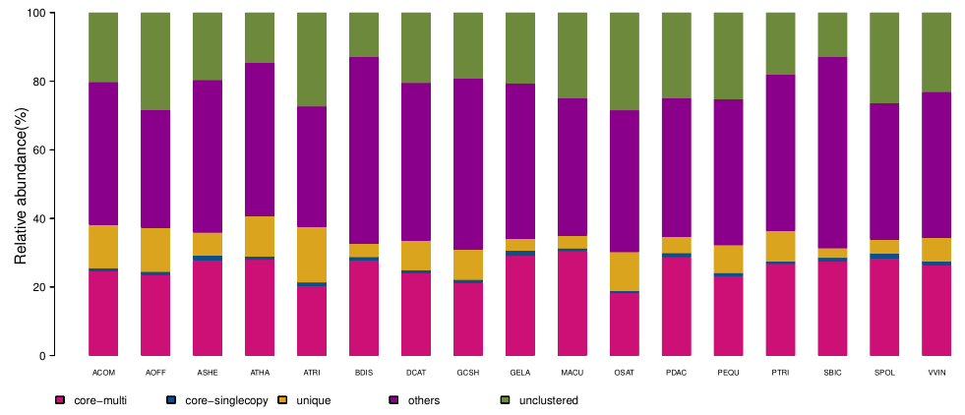

## Supplementary Figure 5. Classification and distribution of homologous gene families among species.



## Supplementary Figure 6. Phylogenetic tree constructed based on the filtered single-copy gene family; each branch length represents the neutral evolution rate.



## Supplementary Figure 7. Phylogenetic analysis of SWEET genes from *A. thaliana*, *D. chrysotoxum*, *P. equestris*, *A. shenzhenica,* and *D. catenatum*. Red gene IDs are expanded genes. Ash, *A. shenzhenica*; Maker, *D. chrysotoxum*; Dca, *D. catenatum*; Peq, *P. equestris*; AT, *A. thaliana*.



## Supplementary Figure 8. Collinear map of *D. chrysotoxum* (Guchui) and *D. catenatum* (DCAT).



## Supplementary Figure 9. Syntenic depths map of *D. chrysotoxum* (Guchui) and *D. catenatum* (DCAT).



## Supplementary Figure 10. Collinear diagram of *D. chrysotoxum* (Guchui) and *P. aphrodite* (PAPH)*.*



## Supplementary Figure 11. Collinear depth distribution map of *D. chrysotoxum* (Guchui) and *P. aphrodite* (PAPH)*.*

**a**

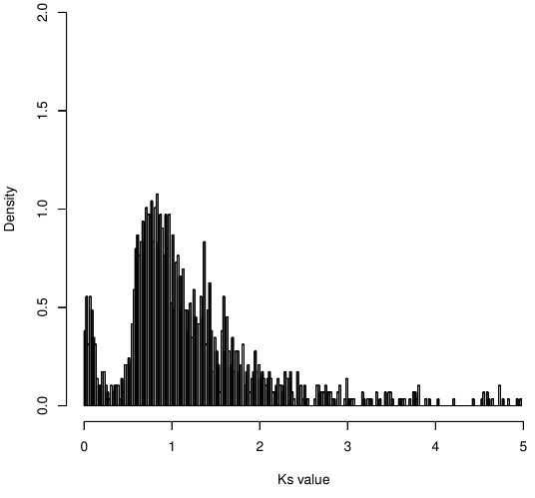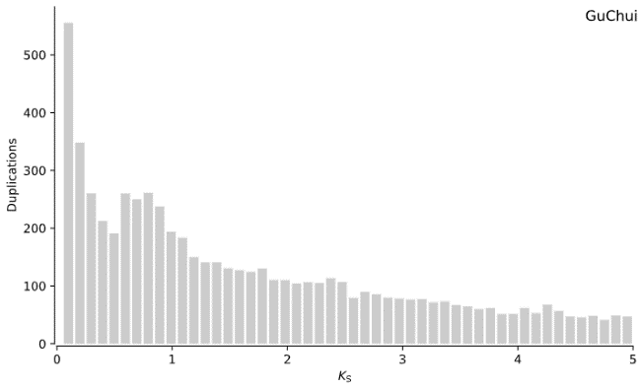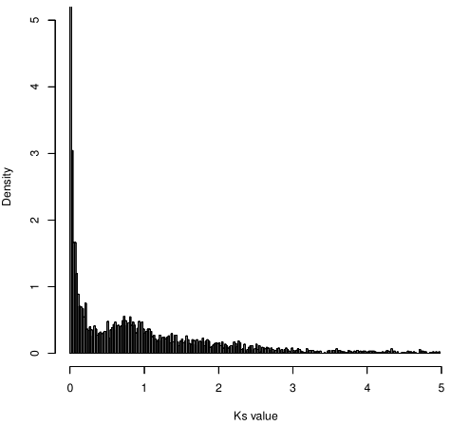

**b**

**c**

## Supplementary Figure 12. *Ks* distribution identified by different methods.a. *Ks* distribution of RBH gene pairs in *D. chrysotoxum*. b. *Ks* distribution identified by WGD software in *D. chrysotoxum*. c. *Ks* distribution of homologous genes in a collinear block of *D. chrysotoxum*. The distribution of *Ks* identified by the above different methods was consistent, and the peak value of *Ks* was at 0.8, which is consistent with the sequenced orchids in previous studies and represents a WGD event experienced by the common ancestor of orchids. The results also support that the earlier the differentiation, the larger the *Ks* peak.

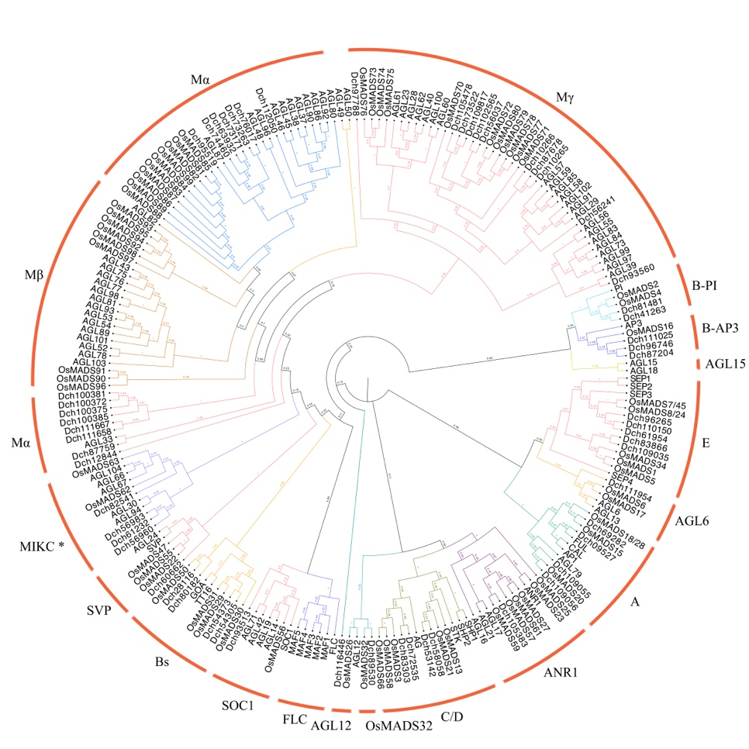

## Supplementary Figure 13. Phylogenetic analysis of MADS-box genes from *D. chrysotoxum*, *Arabidopsis thaliana* and *Oryza sativa*. Dch, *D. chrysotoxum*.



## Supplementary Figure 14. Phylogeny tree of AAO from *Dendrobium chrysotoxum, Dendrobium catenatum, Apostasia shenzhenica, Phalaenopsis equestris,* and *Arabidopsis thaliana* constructed by the PhyML with the Jones–Taylor–Thornton (JTT) matrix-based model. Blue branch showed the AAO clade; red font is the *AAO* gene from *Dendrobium chrysotoxum;* blue font indicated *Arabidopsis AAO* genes.

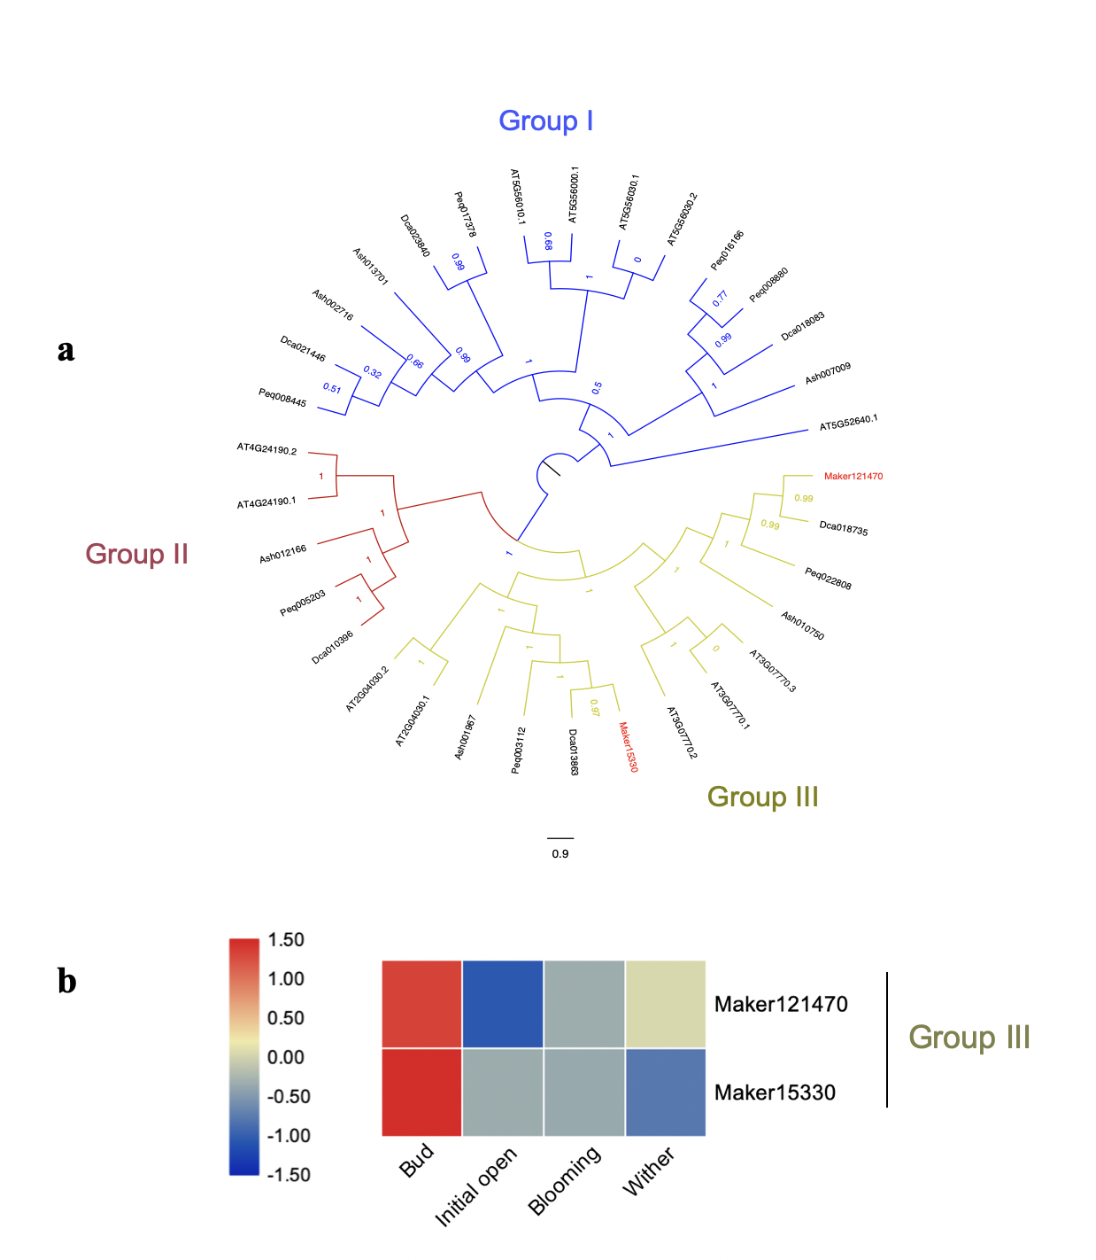

## Supplementary Figure 15. Analysis of *D. chrysotoxum* Hsp90 genes. a. Phylogenetic relationships of *D. chrysotoxum*, *D. catenatum,* *A. shenzhenica, A. thaliana* and *P. equestris* Hsp90 proteins. Ash, *A. shenzhenica*; Maker, *D. chrysotoxum*; Dca, *D. catenatum*; Peq, *P. equestris*; AT, *A. thaliana*. b. Expression patterns of Hsp90 in bud, initial open flower, blooming flower and wither flower of *D. chrysotoxum*.

# Supplementary Tables

## Supplementary Table 1. Summary of DNA sequencing data.

|  |  |  |  |  |  |  |
| --- | --- | --- | --- | --- | --- | --- |
| **Sequencing platform** | **Read type** | **Clean Data (Gb)/ subreads** | **Insert size (bp)** | **Total data (Gb)** | **Read length / Mean subread length (N50) (bp)** | **Sequence coverage**1 **(X)** |
| MGISEQ-2000 | Illumina pair-end reads | 138.15 | 500 | 143.78 | 2 x 150 | 104.19 |
| NovaSeq | Hi-C pair-end reads | 125.96 | 500 | 169.25 | 2 x 150 | 122.64 |
| PacBio Sequel | PacBio subreads | 7,136,946 | - | 132.64 | 12,942.98 (19,505) | 96.12 |

1Depth was calculated under the estimate of a genome size of 1.38 Gb.

## Supplementary Table 2. Summary of Pacbio assembly results of *D. chrysotoxum*.

|  |  |  |  |  |
| --- | --- | --- | --- | --- |
| **Contig** | | | | |
| **Size (bp)** | | | **Number** | |
| N90 | 411,893 | | | 898 |
| N80 | 699,493 | | | 646 |
| N70 | 988,173 | | | 486 |
| N60 | 1,234,715 | | | 364 |
| N50 | 1,540,953 | | | 265 |
| Longest | 8,657,479 | | | - |
| Total Length | 1,367,445,997 | | | - |
| Total Number (>=100 bp) | - | | | 2,302 |
| Total Number (>=2000 bp) | - | | | 2,291 |
| GC Rate | | 0.355 | | |

## Supplementary Table 3. BUSCO assessment of the *D. chrysotoxum* and *P. aphrodite* genomes’ assembly.

|  |  |  |  |
| --- | --- | --- | --- |
| **Species** | **Type** | **Number** | **Percentage** |
|  | Complete BUSCOs(C) | 1,242 | 90.33% |
|  | Complete and single-copy BUSCOs (S) | 1,218 | 88.58% |
|  | Complete and duplicated BUSCOs (D) | 24 | 1.75% |
| *P. aphrodite* | Fragmented BUSCOs (F) | 35 | 2.55% | |
|  | Missing BUSCOs (M) | 98 | 7.13% |
|  | Total BUSCO groups searched | 1,375 | - |
|  |  |  |  |
|  | Complete BUSCOs(C) | 1,242 | 90.33% |
|  | Complete and single-copy BUSCOs (S) | 1,125 | 81.82% |
| *D. chrysotoxum* | Complete and duplicated BUSCOs (D) | 117 | 8.51% |
|  | Fragmented BUSCOs (F) | 49 | 3.56% |
|  | Missing BUSCOs (M) | 84 | 6.11% |
|  | Total BUSCO groups searched | 1,375 | - |

## Supplementary Table 4. Chromosome length by Hi-C assembly.

|  |  |  |  |
| --- | --- | --- | --- |
| **Chromosome ID** | **Contig number** | **Length(bp)** | **Length ratio** |
| Chr01 | 75 | 58,699,466 | 4.29% |
| Chr02 | 57 | 60,674,785 | 4.43% |
| Chr03 | 56 | 38,283,235 | 2.80% |
| Chr04 | 102 | 81,914,847 | 5.99% |
| Chr05 | 73 | 60,425,906 | 4.42% |
| Chr06 | 117 | 98,428,665 | 7.19% |
| Chr07 | 76 | 57,422,580 | 4.20% |
| Chr08 | 83 | 45,230,344 | 3.31% |
| Chr09 | 99 | 98,780,041 | 7.22% |
| Chr10 | 50 | 53,244,469 | 3.89% |
| Chr11 | 114 | 67,798,029 | 4.96% |
| Chr12 | 63 | 60,234,544 | 4.40% |
| Chr13 | 62 | 60,242,052 | 4.40% |
| Chr14 | 65 | 47,375,978 | 3.46% |
| Chr15 | 39 | 46,988,260 | 3.43% |
| Chr16 | 99 | 87,905,214 | 6.42% |
| Chr17 | 94 | 94,615,362 | 6.92% |
| Chr18 | 82 | 100,493,053 | 7.34% |
| Chr19 | 93 | 91,318,610 | 6.67% |
| UN | 805 | 58111057 | 4.25% |

## Supplementary Table 5. Summary of HiC-assembly results.

|  |  |  |  |  |  |  |  |
| --- | --- | --- | --- | --- | --- | --- | --- |
| **Contig** | | | | **Scaffold** | | | |
| **Size(bp)** | | **Number** | | **Size(bp)** | | **Number** | |
| N90 | 411,893 | | 898 | | 45,230,344 | | 18 |
| N80 | 696,269 | | 647 | | 53,244,469 | | 15 |
| N70 | 984,844 | | 486 | | 60,234,544 | | 12 |
| N60 | 1,234,715 | | 364 | | 60,425,906 | | 10 |
| N50 | 1,540,953 | | 265 | | 67,798,029 | | 8 |
| Longest | 8,657,479 | | - | | 100,493,053 | | - |
| Total Length | 1,367,445,997 | | - | | 1,310,075,440 | | - |
| Total Number (>=100 bp) | - | | 2304 | | - | | 823 |

## Supplementary Table 6. Summary of orthologous gene families in 17 sequenced plant species.

|  |  |  |  |  |  |  |  |  |  |  |
| --- | --- | --- | --- | --- | --- | --- | --- | --- | --- | --- |
| **Species** | **Genes** | **Unclustered genes** | **Clustered genes** | **Families** | **Unique families** | **Unique family genes** | **Common families** | **Common family genes** | **Single copy** | **Average genes per family** |
| *A. comosus* | 27,024 | 5,462 | 21,562 | 12,942 | 787 | 3,408 | 3,785 | 6,907 | 274 | 1.666 |
| *A. officinalis* | 27,375 | 7,773 | 19,602 | 11,940 | 836 | 3,512 | 3,785 | 6,699 | 274 | 1.642 |
| *A. shenzhenica* | 20,560 | 4,032 | 16,528 | 11,808 | 335 | 1,390 | 3,785 | 5,995 | 274 | 1.4 |
| *A. thaliana* | 27,416 | 3,993 | 23,423 | 12,653 | 781 | 3,212 | 3,785 | 7,938 | 274 | 1.851 |
| *A. trichopoda* | 25,933 | 7,083 | 18,850 | 12,238 | 985 | 4,210 | 3,785 | 5,538 | 274 | 1.54 |
| *B. distachyon* | 26,415 | 3,402 | 23,013 | 14,917 | 352 | 1,014 | 3,785 | 7,600 | 274 | 1.543 |
| *D. catenatum* | 26,791 | 5,483 | 21,308 | 14,092 | 578 | 2,297 | 3,785 | 6,695 | 274 | 1.512 |
| *D. chrysotoxum* | 30,044 | 5,765 | 24,280 | 13,324 | 606 | 2,633 | 3,785 | 6,657 | 274 | 1.822 |
| *G. elata* | 18,019 | 3,715 | 14,304 | 10,545 | 229 | 610 | 3,785 | 5,521 | 274 | 1.356 |
| *M. acuminata* | 34,241 | 8,517 | 25,724 | 12,540 | 486 | 1,242 | 3,785 | 10,721 | 274 | 2.051 |
| *O. sativa* | 42,189 | 11,999 | 30,190 | 16,547 | 1,265 | 4,787 | 3,785 | 7,959 | 274 | 1.824 |
| *P. dactylifera* | 23,890 | 5,972 | 17,918 | 10,826 | 369 | 1,115 | 3,785 | 7,146 | 274 | 1.655 |
| *P. equestris* | 26,471 | 6,679 | 19,792 | 13,495 | 636 | 2,142 | 3,785 | 6,388 | 274 | 1.467 |
| *P. trichocarpa* | 40,984 | 7,407 | 33,577 | 14,108 | 1,177 | 3,676 | 3,785 | 11,253 | 274 | 2.38 |
| *S. bicolor* | 27,160 | 3,473 | 23,687 | 15,312 | 294 | 767 | 3,785 | 7,749 | 274 | 1.547 |
| *S. polyrhiza* | 18,357 | 4,841 | 13,516 | 10,064 | 248 | 741 | 3,785 | 5,475 | 274 | 1.343 |
| *V. vinifera* | 25,328 | 5,847 | 19,481 | 12,576 | 595 | 1,736 | 3,785 | 6,956 | 274 | 1.549 |

Note: Unclustered genes refers to the number of genes unique to the species; Unique families refers to gene families unique to the species.

## Supplementary Table 7. BUSCO assessment of the *D. chrysotoxum* and *P. aphrodite* genomes’ annotation.

|  |  |  |  |
| --- | --- | --- | --- |
| **Species** | **Type** | **Number** | **Percentage** |
|  | Complete BUSCOs(C) | 1,297 | 94.32% |
|  | Complete and single-copy BUSCOs (S) | 1,274 | 92.65% |
|  | Complete and duplicated BUSCOs (D) | 23 | 1.67% |
| *P. aphrodite* | Fragmented BUSCOs (F) | 28 | 2.04% |
|  | Missing BUSCOs (M) | 50 | 3.64% |
|  | Total BUSCO groups searched | 1,375 | - |
|  |  |  |  |
|  | Complete BUSCOs(C) | 1315 | 95.64% |
|  | Complete and single-copy BUSCOs (S) | 1235 | 89.82% |
| *D. chrysotoxum* | Complete and duplicated BUSCOs (D) | 80 | 5.82% |
|  | Fragmented BUSCOs (F) | 20 | 1.45% |
|  | Missing BUSCOs (M) | 40 | 2.91% |
|  | Total BUSCO groups searched | 1,375 | - |

## Supplementary Table 8. Prediction of gene structures in *D. chrysotoxum*.

|  |  |  |  |  |  |  |  |
| --- | --- | --- | --- | --- | --- | --- | --- |
|  | **Gene set** | **Number** | **Average** | **Average** | **Average** | **Average** | **Average** |
|  | **mRNA** | **CDS** | **exon per** | **exon** | **intron** |
|  | **length (bp)** | **length (bp)** | **gene** | **length (bp)** | **length (bp)** |
| Denovo | Augustus | 49,763 | 5281.51 | 839.03 | 2.83 | 296.77 | 2431.3 |
| SNAP | 145,612 | 5085.98 | 490.97 | 2.88 | 170.63 | 2447.5 |
| Homolog | *Arabidopsis thaliana* | 59,398 | 6078.15 | 881.47 | 3.22 | 273.92 | 2342.99 |
| *Oryza sativa* | 70,498 | 5649.71 | 850.58 | 3.02 | 281.96 | 2379.77 |
| *Sorghum bicolor* | 62,870 | 6219.25 | 891.2 | 3.27 | 272.95 | 2352.28 |
| *Zea mays* | 85,147 | 4872.26 | 715.26 | 2.82 | 253.26 | 2278.73 |
| *Gastrodia elata* | 54,950 | 5920.87 | 836.66 | 3.16 | 265.11 | 2358.35 |
| *Phalaenopsis equestris* | 136,048 | 3443.8 | 606.14 | 2.29 | 265.05 | 2205.14 |
| RNA-seq | -- | 33387 | 16066.78 | 1667.93 | 5.32 | 313.62 | 3334.38 |
| Maker | -- | 30,044 | 10947.05 | 1033.86 | 4.5 | 229.98 | 2642.87 |

## Supplementary Table 9. Statistics of non-coding RNA in the *D. chrysotoxum* genome.

|  |  |  |  |  |  |
| --- | --- | --- | --- | --- | --- |
| **Type** | | **Copy** | **Average length (bp)** | **Total length (bp)** | **% of genome** |
| miRNA | | 80 | 124.39 | 9,951 | 0.000396 |
| tRNA | | 1,285 | 74.86 | 96,199 | 0.025358 |
| rRNA | rRNA | 2,275 | 280.17 | 637,379 | 0.025358 |
| 18S | 347 | 1121.48 | 389,154 | 0.015483 |
| 28S | 813 | 141.78 | 115,264 | 0.004586 |
| 5.8S | 203 | 155.8 | 31,628 | 0.001258 |
| 5S | 912 | 111.11 | 101,333 | 0.004032 |
| snRNA | snRNA | 882 | 111.06 | 97,955 | 0.003897 |
| CD-box | 652 | 105.77 | 68,960 | 0.002744 |
| HACA-box | 18 | 128 | 2,304 | 0.000092 |
| splicing | 212 | 125.9 | 26,691 | 0.001062 |

## Supplementary Table 10. Statistical results of repeat sequences.

|  |  |  |
| --- | --- | --- |
| **Type** | **Repeat Size(bp)** | **% of genome** |
| TRF | 60,980,312 | 4.459431 |
| RepeatMasker | 209,193,906 | 15.298148 |
| RepeatProteinMask | 314,744,165 | 23.016936 |
| De novo | 771,808,868 | 56.441634 |
| Total | 858,835,374 | 62.805798 |

## Supplementary Table 11. Statistics of repeat sequences in *D. chrysotoxum*.

|  |  |  |  |  |  |  |  |  |
| --- | --- | --- | --- | --- | --- | --- | --- | --- |
|  | **RepBase TEs** | | **TE Proteins** | | **De novo** | | **Combined TEs** | |
|  | **Length** | **%in** | **Length** | **%in** | **Length** | **%in** | **Length** | **%in** |
|  | **(bp)** | **Genome** | **(bp)** | **Genome** | **(bp)** | **Genome** | **(bp)** | **Genome** |
| DNA | 13,675,689 | 1.00009 | 16,523,144 | 1.208322 | 9,467,177 | 0.692325 | 28,778,046 | 2.104511 |
| LINE | 38,965,431 | 2.849504 | 79,065,271 | 5.781967 | 71,655,790 | 5.240118 | 132,460,276 | 9.686692 |
| SINE | 231,405 | 0.016922 | 0 | 0 | 0 | 0 | 231,405 | 0.016922 |
| LTR | 158,486,236 | 11.589945 | 219,653,630 | 16.063057 | 690,356,601 | 50.485109 | 726,773,563 | 53.148246 |
| Other | 5,284 | 0.000386 | 0 | 0 | 0 | 0 | 5,284 | 0.000386 |
| Unknown | 0 | 0 | 0 | 0 | 6,571,394 | 0.48056 | 6,571,394 | 0.48056 |
| Total | 209,193,906 | 15.298148 | 314,744,165 | 23.016936 | 765,020,013 | 55.945172 | 837,103,567 | 61.216572 |

*LINE, long interspersed nuclear element; SINE, short interspersed element; LTR, long terminal repeat.

*Denovo+Repbase denotes transposable elements identified by RepeatMasker (<http://www.repeatmasker.org>) with default options after RepeatModeler/RepeatScout/Piler/LTR_finder software used with RepBase database prediction.

*TE proteins were transposable elements identified in the genome through the annotation of Repeat ProteinMask software using the RepBase database.

*Combined TEs involved a combination of the above two methods.

*Unknown repeat sequences could not be clustered by Repeat Masker.

## Supplementary Table 12. Statistical results of functional annotation.

|  |  |  |  |  |  |  |  |  |  |
| --- | --- | --- | --- | --- | --- | --- | --- | --- | --- |
| **Values** | **Total** | **Nr** | **Swissprot** | **KEGG** | **KOG** | **TrEMBL** | **Interpro** | **GO** | **Overall** |
| Number | 30,044 | 26,809 | 19,186 | 18,667 | 17,414 | 27,269 | 22,736 | 5,462 | 27,576 |
| Percentage | - | 89.23% | 63.86% | 62.13% | 57.96% | 90.76% | 75.67% | 18.18% | 91.78% |

## Supplementary Table 13. Gene Ontology (GO) enrichment results of significantly expanded gene families in *D. chrysotoxum* (see separate files).

## Supplementary Table 14. Statistical results of whole gene collinearity analysis.

|  |  |  |  |  |  |  |
| --- | --- | --- | --- | --- | --- | --- |
| **Species 1** | **Species 2** | **Genes** | **Collinear blocks** | **Mean genes in one block** | **Collinear genes** | **Percentage (%)** |
| *D. chrysotoxum* | *D. chrysotoxum* | 30045 | 231 | 6.67 | 2800 | 9.32 |
| *D. chrysotoxum* | *D. catenatum* | 56836 | 1149 | 10.95 | 24550 | 43.19 |
| *D. chrysotoxum* | *P. equestris* | 56516 | 838 | 13.44 | 21881 | 38.72 |
| *D. chrysotoxum* | *P. aphrodite* | 49718 | 277 | 39.93 | 21592 | 21592 |

**Supplementary Table 15. List of MADS-box genes identified in *D. chrysotoxum*.**

|  |  |  |  |  |
| --- | --- | --- | --- | --- |
| **Gene ID** | **Gene name** | **ORF (bp)** | **Protein (aa)** | **Subfamily** |
| Maker100372 | Dch100372 | 1614 | 537 | A |
| Maker100375 | Dch100375 | 1302 | 433 | A |
| Maker100381 | Dch100381 | 375 | 124 | AGL6 |
| Maker100385 | Dch100385 | 951 | 316 | ANR1 |
| Maker102565 | Dch102565 | 711 | 236 | AP3 |
| Maker10265 | Dch10265 | 576 | 191 | AP3 |
| Maker10266 | Dch10266 | 909 | 302 | AP3 |
| Maker105383 | Dch105383 | 1050 | 349 | AP3 |
| Maker105478 | Dch105478 | 348 | 115 | Bs |
| Maker109055 | Dch109055 | 1047 | 349 | C/D |
| Maker109817 | Dch109817 | 1179 | 392 | C/D |
| Maker110150 | Dch110150 | 855 | 284 | C/D |
| Maker111025 | Dch111025 | 909 | 301 | C/D |
| Maker111658 | Dch111658 | 636 | 211 | E |
| Maker111667 | Dch111667 | 636 | 211 | E |
| Maker111954 | Dch111954 | 1056 | 351 | E |
| Maker112050 | Dch112050 | 723 | 240 | E |
| Maker28116 | Dch28116 | 315 | 104 | M alpha |
| Maker41263 | Dch41263 | 633 | 210 | M alpha |
| Maker53142 | Dch53142 | 759 | 252 | M alpha |
| Maker54373 | Dch54373 | 519 | 173 | M alpha |
| Maker56037 | Dch56037 | 657 | 218 | M alpha |
| Maker56241 | Dch56241 | 732 | 243 | M alpha |
| Maker58058 | Dch58058 | 672 | 223 | M alpha |
| Maker61232 | Dch61232 | 1050 | 349 | M alpha |
| Maker61954 | Dch61954 | 879 | 292 | M alpha |
| Maker63932 | Dch63932 | 753 | 250 | M alpha |
| Maker69282 | Dch69282 | 699 | 232 | M gamma |
| Maker72535 | Dch72535 | 597 | 198 | M gamma |
| Maker73171 | Dch73171 | 750 | 249 | M gamma |
| Maker74460 | Dch74460 | 753 | 270 | M gamma |
| Maker76017 | Dch76017 | 723 | 240 | M gamma |
| Maker81481 | Dch81481 | 567 | 188 | M gamma |
| Maker82541 | Dch82541 | 837 | 278 | M gamma |
| Maker83303 | Dch83303 | 870 | 189 | M gamma |
| Maker83866 | Dch83866 | 822 | 273 | M gamma |
| Maker87204 | Dch87204 | 684 | 227 | M gamma |
| Maker87678 | Dch87678 | 675 | 224 | M gamma |
| Maker87759 | Dch87759 | 1053 | 350 | M gamma |
| Maker89530 | Dch89530 | 579 | 192 | MIKc* |
| Maker95519 | Dch95519 | 735 | 244 | MIKc* |
| Maker96265 | Dch96265 | 972 | 323 | PI |
| Maker96746 | Dch96746 | 657 | 218 | PI |
| Maker97788 | Dch97788 | 483 | 160 | SOC1 |

## Supplementary Table 16. The expression of genes in carotenoid biosynthesis pathway and regulatory mechanisms.

|  |  |  |  |  |  |  |  |  |  |  |  |
| --- | --- | --- | --- | --- | --- | --- | --- | --- | --- | --- | --- |
| **Name** | **Gene ID** | **Bud** | **IniOp** | **Blm** | **Fd** | **Stem1** | **Stem2** | **Stem3** | **Leaf1** | **Leaf2** | **Leaf3** |
| PSY | Maker83370 | 53.39 | 57.00 | 20.46 | 14.59 | 50.10 | 59.93 | 39.89 | 109.36 | 153.96 | 118.06 |
| PSY | Maker32731 | 14.72 | 63.11 | 46.08 | 32.67 | 0.39 | 0.30 | 0.08 | 0.26 | 0.39 | 0.15 |
| OR | Maker66469 | 65.48 | 173.14 | 101.22 | 84.43 | 24.56 | 36.17 | 34.84 | 79.59 | 88.12 | 74.60 |
| OR-LIKE | Maker111682 | 58.11 | 94.25 | 87.47 | 89.43 | 82.64 | 112.95 | 96.44 | 112.61 | 125.38 | 131.89 |
| CLPB3 | Maker84981 | 36.50 | 41.75 | 31.87 | 26.92 | 142.88 | 85.05 | 111.53 | 54.14 | 51.20 | 85.45 |
| DXS | Maker86880 | 70.33 | 124.46 | 49.46 | 38.93 | 31.10 | 44.91 | 31.31 | 27.27 | 28.06 | 30.94 |
| Maker86884 | 67.91 | 114.46 | 34.95 | 35.59 | 26.00 | 34.35 | 32.14 | 28.36 | 25.62 | 29.98 |
| PDS | Maker54122 | 145.57 | 1414.56 | 352.87 | 413.04 | 11.51 | 17.22 | 15.57 | 34.49 | 33.17 | 25.29 |
| Z-ISO | Maker73577 | 42.91 | 134.42 | 50.56 | 46.09 | 14.31 | 20.00 | 18.92 | 28.31 | 25.56 | 22.71 |
| ZDS | Maker100941 | 128.70 | 745.29 | 474.05 | 410.99 | 41.46 | 47.12 | 46.07 | 80.63 | 76.92 | 80.38 |
| CTRISO | Maker59413 | 16.81 | 42.88 | 50.78 | 64.35 | 6.74 | 8.43 | 7.55 | 13.22 | 12.49 | 12.75 |
| LYCB | Maker67572 | 17.48 | 37.87 | 29.20 | 29.11 | 16.32 | 21.33 | 23.67 | 35.37 | 41.20 | 35.22 |
| LYCE | Maker70264 | 17.52 | 12.91 | 3.82 | 3.37 | 15.61 | 16.85 | 11.60 | 20.93 | 19.49 | 20.34 |
| PGM48 | Maker110151 | 15.71 | 66.34 | 45.55 | 55.19 | 18.49 | 18.18 | 19.05 | 80.31 | 69.09 | 66.28 |
| CYP97A3 | Maker86659 | 112.66 | 479.24 | 238.46 | 276.03 | 26.78 | 33.35 | 27.41 | 99.70 | 95.78 | 80.63 |
| CYP97C1 | Maker116351 | 21.30 | 28.70 | 12.98 | 9.30 | 4.64 | 6.41 | 5.64 | 20.10 | 16.03 | 17.19 |
| CYP97C1 | Maker51218 | 1.05 | 0.30 | 0.44 | 0.12 | 0.49 | 0.46 | 0.40 | 1.90 | 2.15 | 2.13 |
| CYP97C1 | Maker121734 | 24.85 | 37.86 | 13.68 | 14.77 | 2.80 | 3.34 | 3.53 | 14.31 | 11.79 | 12.41 |
| BCH | Maker65814 | 7.80 | 14.03 | 6.76 | 5.97 | 31.84 | 32.88 | 30.25 | 9.69 | 14.59 | 12.11 |
| BCH | Maker109431 | 157.50 | 1800.20 | 902.77 | 659.40 | 0.00 | 0.12 | 0.07 | 0.03 | 0.03 | 0.00 |
| ZEP | Maker82479 | 8.60 | 4.14 | 2.75 | 3.39 | 7.02 | 20.94 | 11.07 | 33.67 | 31.80 | 27.32 |
| VDE | Maker89122 | 23.16 | 24.49 | 20.53 | 17.69 | 8.67 | 8.81 | 9.88 | 19.88 | 23.92 | 14.98 |
| ABA4-NXS | Maker113481 | 78.34 | 37.51 | 20.26 | 20.42 | 5.72 | 4.58 | 6.79 | 8.53 | 8.32 | 6.72 |
| ABA4-NXS | Maker118392 | 16.81 | 9.29 | 0.72 | 2.13 | 0.12 | 0.51 | 0.28 | 0.07 | 0.00 | 0.00 |
| XAT | Maker66153 | 315.36 | 87.18 | 28.54 | 1.78 | 0.92 | 1.02 | 1.79 | 0.98 | 1.34 | 1.02 |
| CCD4 | Maker99416 | 0.00 | 0.00 | 0.00 | 0.00 | 0.00 | 0.00 | 0.00 | 0.00 | 0.00 | 0.00 |
| Maker107515 | 0.00 | 0.00 | 0.00 | 0.00 | 0.00 | 0.00 | 0.00 | 0.00 | 0.00 | 0.00 |
| Maker99401 | 0.03 | 0.00 | 0.00 | 0.03 | 0.87 | 2.04 | 0.95 | 3.82 | 1.03 | 2.14 |
| Maker114782 | 0.19 | 0.00 | 0.03 | 0.00 | 0.10 | 0.15 | 0.10 | 16.90 | 6.76 | 14.90 |
| Maker99378 | 0.00 | 0.00 | 0.00 | 0.00 | 0.00 | 0.00 | 0.00 | 0.29 | 0.00 | 0.00 |
| Maker99339 | 0.00 | 0.00 | 0.00 | 0.00 | 0.00 | 0.00 | 0.00 | 0.00 | 0.00 | 0.00 |
| Maker107530 | 0.00 | 0.00 | 0.00 | 0.00 | 0.00 | 0.00 | 0.00 | 0.00 | 0.00 | 0.00 |
| CCD8 | Maker114213 | 1.43 | 0.24 | 0.00 | 0.07 | 11.72 | 2.15 | 4.06 | 0.00 | 0.00 | 0.00 |
| Maker117913 | 1.37 | 0.12 | 0.00 | 0.00 | 2.88 | 0.66 | 1.01 | 0.03 | 0.00 | 0.03 |
| CCD7 | Maker116019 | 0.03 | 0.00 | 0.00 | 0.03 | 0.24 | 0.66 | 0.87 | 0.00 | 0.00 | 0.00 |
| Maker67149 | 0.00 | 0.00 | 0.00 | 0.00 | 0.00 | 0.00 | 0.00 | 0.00 | 0.00 | 0.00 |
| Maker67132 | 1.95 | 0.57 | 1.26 | 0.76 | 0.04 | 0.00 | 0.00 | 0.02 | 0.13 | 0.00 |

Green color: the gene expression increased gradually; orange colour: the gene expression decreased gradually.

## Supplementary Table 17. The expression of gene in abscisic acid biosynthesis pathway.

|  |  |  |  |  |  |  |  |  |  |  |  |
| --- | --- | --- | --- | --- | --- | --- | --- | --- | --- | --- | --- |
| **Name** | **Gene ID** | **Bud** | **IniOp** | **Blm** | **Fd** | **Stem1** | **Stem2** | **Stem3** | **Leaf1** | **Leaf2** | **Leaf3** |
| NCED | Maker56123 | 0.06 | 0.63 | 0.48 | 0.79 | 3.68 | 2.08 | 7.04 | 0.09 | 0.13 | 0.00 |
| Maker69003 | 11.70 | 6.27 | 5.73 | 11.88 | 2.92 | 2.51 | 4.98 | 4.64 | 5.79 | 4.66 |
| SDR1 | Maker95296 | 19.52 | 22.47 | 19.40 | 17.82 | 10.13 | 9.95 | 11.69 | 12.90 | 13.57 | 12.16 |
| SDR2 | Maker93730 | 0.55 | 1.07 | 1.25 | 1.26 | 0.00 | 0.10 | 0.00 | 85.85 | 56.40 | 26.52 |
| AAO | Maker111635 | 8.37 | 3.71 | 2.79 | 1.57 | 1.25 | 1.12 | 1.53 | 0.88 | 0.72 | 0.76 |
| MOCO | Maker60410 | 6.10 | 6.41 | 5.27 | 5.96 | 6.51 | 6.83 | 7.49 | 9.32 | 8.92 | 8.02 |
| Maker60384 | 4.64 | 6.59 | 3.24 | 5.29 | 3.58 | 3.02 | 3.68 | 5.64 | 5.62 | 5.18 |
| Maker59665 | 20.74 | 22.52 | 18.66 | 19.65 | 8.85 | 11.42 | 11.21 | 11.08 | 11.51 | 11.40 |
| Maker58183 | 10.12 | 6.58 | 3.14 | 3.56 | 1.23 | 0.53 | 0.70 | 5.75 | 8.77 | 3.22 |
| Maker13158 | 13.63 | 15.32 | 6.38 | 2.16 | 0.52 | 0.13 | 0.05 | 0.48 | 0.56 | 0.28 |

Green color: the gene expression increased gradually; orange color: the gene expression decreased gradually.

## Supplementary Table 18. The expression of genes in Ethylene biosynthesis pathway and regulatory mechanisms.

|  |  |  |  |  |  |  |  |  |  |  |  |
| --- | --- | --- | --- | --- | --- | --- | --- | --- | --- | --- | --- |
| **Name** | **Gene ID** | **Bud** | **IniOp** | **Blm** | **Fd** | **Stem1** | **Stem2** | **Stem3** | **Leaf1** | **Leaf2** | **Leaf3** |
| SAM1/2 | Maker79017 | 2101.39 | 2316.12 | 3275.54 | 2719.31 | 308.90 | 789.44 | 317.14 | 328.35 | 315.76 | 216.95 |
| ACS10/12 | Maker60889 | 11.32 | 19.27 | 12.26 | 11.43 | 6.95 | 8.72 | 8.00 | 19.22 | 17.67 | 16.68 |
| Maker120658 | 24.70 | 22.37 | 15.94 | 18.38 | 62.36 | 75.97 | 57.69 | 93.35 | 85.03 | 96.68 |
| ACS9/5/4/8/11 | Maker105598 | 0.12 | 0.41 | 0.08 | 0.29 | 0.03 | 0.11 | 0.03 | 0.09 | 0.03 | 0.00 |
| ACS2/1/6 | Maker109266 | 0.78 | 0.74 | 0.08 | 0.40 | 0.00 | 0.00 | 0.03 | 0.06 | 0.09 | 0.00 |
| ACS7 | Maker75695 | 0.87 | 3.19 | 1.91 | 1.19 | 0.00 | 0.00 | 0.10 | 0.03 | 0.03 | 0.17 |
| Maker97433 | 0.00 | 0.00 | 0.00 | 0.04 | 0.00 | 0.00 | 0.00 | 0.00 | 0.00 | 0.00 |
| Maker66290 | 0.05 | 0.16 | 0.81 | 20.30 | 0.03 | 0.00 | 0.00 | 0.00 | 0.00 | 0.04 |
| ACO4 | Maker29641 | 899.31 | 2456.81 | 975.47 | 1680.31 | 18.86 | 37.94 | 52.93 | 1124.47 | 1164.27 | 158.14 |
| ACO5 | Maker77098 | 0.49 | 0.15 | 0.36 | 0.07 | 0.00 | 0.00 | 0.00 | 0.16 | 0.00 | 0.05 |
| Maker77030 | 4.12 | 0.45 | 4.83 | 1.22 | 0.09 | 0.00 | 0.05 | 0.47 | 0.56 | 0.16 |
| EIN2 | Maker78483 | 28.22 | 36.07 | 39.67 | 43.12 | 45.37 | 40.31 | 48.17 | 35.33 | 41.69 | 38.08 |
| CTR1 | Maker00834 | 32.77 | 29.26 | 23.52 | 26.19 | 25.23 | 26.54 | 32.46 | 23.25 | 27.25 | 24.16 |

Green color: the gene expression increased gradually;